IFT 598: Middleware Prog & Database Sec (2022 Fall)

Module 4 Assignment: Creating a NoSQL Database in MongoDB Atlas

Name: Jyoshnapriya Buddhi

Class: 2022Fall-P-IFT458-IFT598-82341-82345

Date: 10-23-2022

**Initializing project variables:**

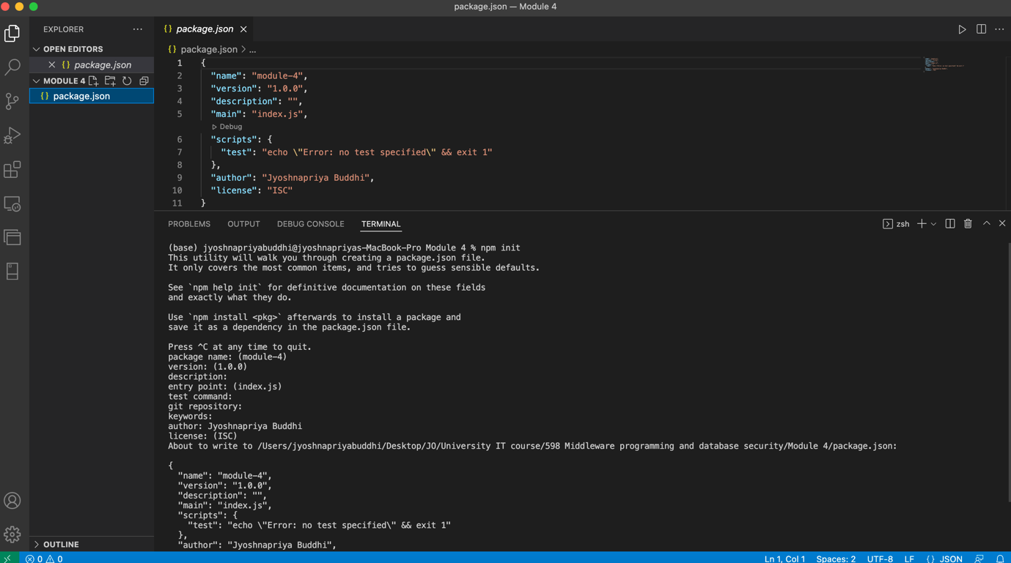

**Step 1: config.env**

**Step 2: loanRoutes.js, loanModel.js**

loanRoutes.js:

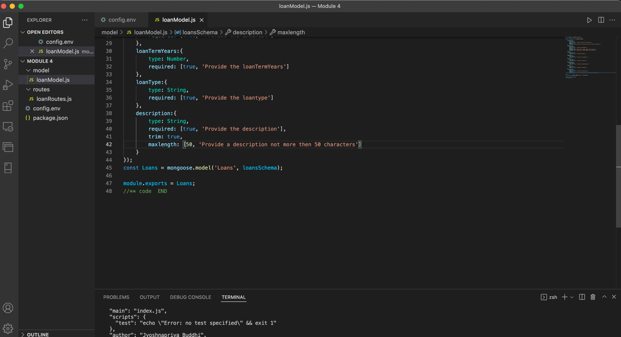

**Step 3: server.js**

**Step 4: Create “ "loanDbContext.js”**

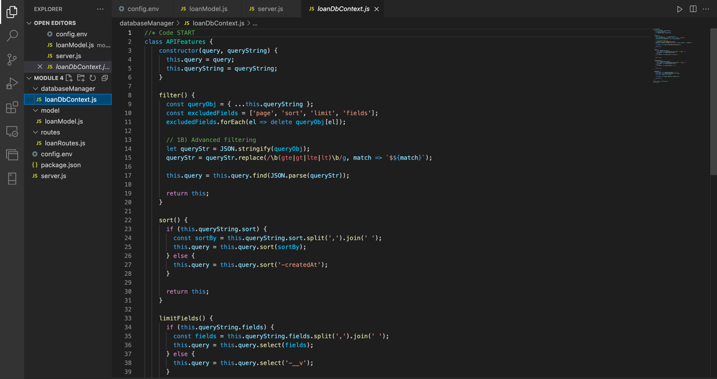

**Step 5: loanController.js**

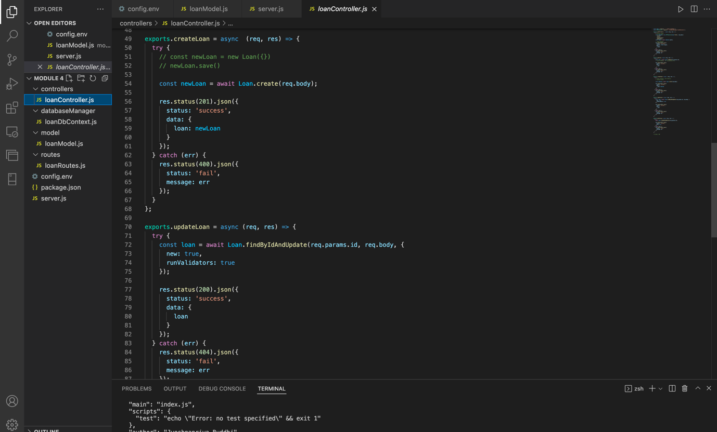

**Step 6: app.js**

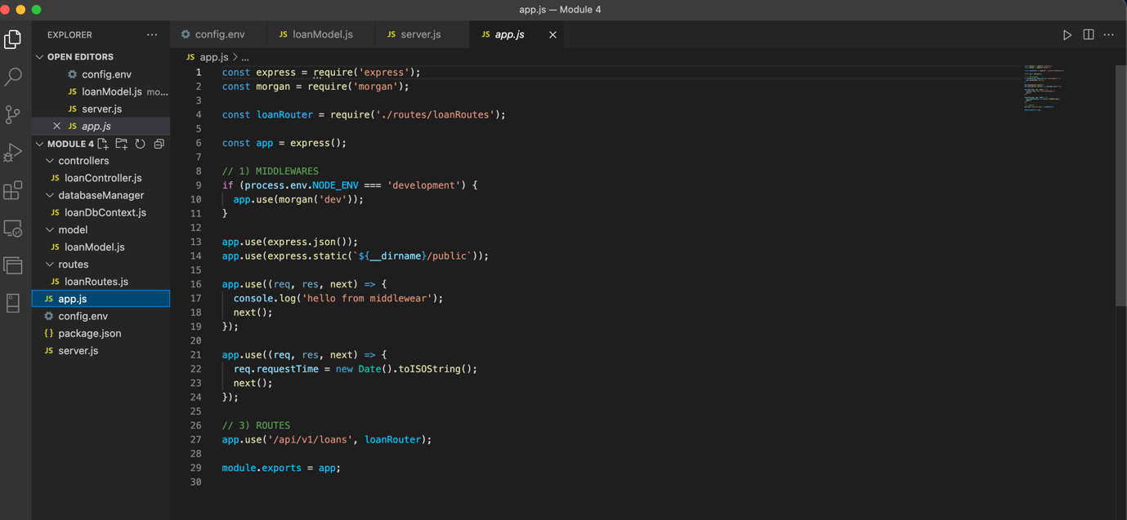

**Executing the project:**

Node server.js:

App running on port 3000

Database connection along with connection string:

**Posting 5 loan data:**

Display the documents:

**Get the values from the url in browser:**

**http://localhost:3000/api/v1/loans**

**Updating the value of JSON object using PUT:**

Checking for change in the data:

**Deleting a user using id:**

Let us delete our updated user Anthony Davis

Checking if the customer is deleted form the database

We can see the customer is deleted and we have 4 entries in the database instead of 5

